1. Set up screen
   * Age, name and other demographics
   * Information about pregnancy (born, not born etc.)
   * **Make the application personal**
2. Begin screen, choose between **I WANT TO PREVENT RELAPSE** or **I’M A PARTNER**
   * If partner 🡪 smoker or non-smoker
   * If partner provide some information about how you can help someone from relapsing

Mogelijke mensen:

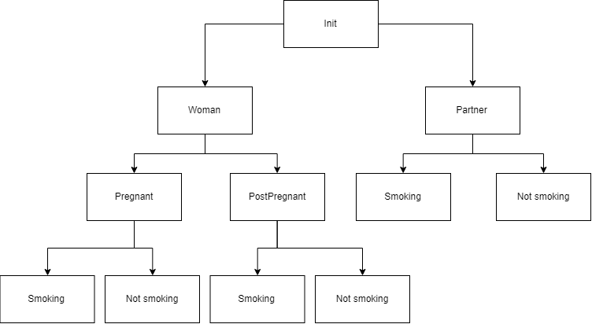

1. PregnantSmoking
2. PregnantNotSmoking
3. PostPregnantSmoking
4. PostPregnantNotSmoking
5. PartnerSmoking
6. PartnerNotSmoking

Postpartum women are particularly vulnerable to smoking relapse due to factors such as perception of no longer needing to protect the baby, stress of dealing with a new infant, lack of confidence in remaining quit, nicotine dependence, living with a smoking partner, and a desire to return to their pre-pregnancy identity

infants exposed to second hand smoke have a higher incidence of sudden infant death, respiratory conditions including asthma, bronchitis and pneumonia, and other infections such as middle ear disease and meningitis

We identified six promising BCTs to prevent postpartum smoking relapse based on a structured systematic review of published available evidence. Future interventions should consider the inclusion of BCTs addressing problem solving and how to maintain abstinent behaviour, information on health and other consequences of smoking, reducing negative emotions and improving the likelihood of smoking abstinence through the provision of social support.